CSE 581

**Lab 13: Error Handling**

**Nidhi Surya Prakash**

**SUID:215895619**

**Purpose:**

Write an SP with an error handler.

**Steps:**

1. Create a stored procedure: The SP should accept 2 parameters (let’s say A and B) and return the result of A divided by B. The SP should do error handling[1], and if an error occurs, it should print out *“An error has occurred”* and ***return*** -1 as a result. Provide a **screenshot** of SP creation.

Script :

CREATE PROCEDURE nsuryapr.DivideErrorCheck (

                                 @A AS INT,

                                 @B AS INT

                                 )

AS

     DECLARE @OutPrint VARCHAR(MAX);

DECLARE @Result INT;

        BEGIN TRY

SELECT @Result = @A / @B

        END TRY

        BEGIN CATCH

SELECT @Result = -1

     SET @OutPrint='An error has occurred, Try Again';

            PRINT @OutPrint;

PRINT @Result;

            --ROLLBACK TRAN;

            RETURN;

        END CATCH;

    PRINT @OutPrint;

PRINT @Result;

;

Script Execution:

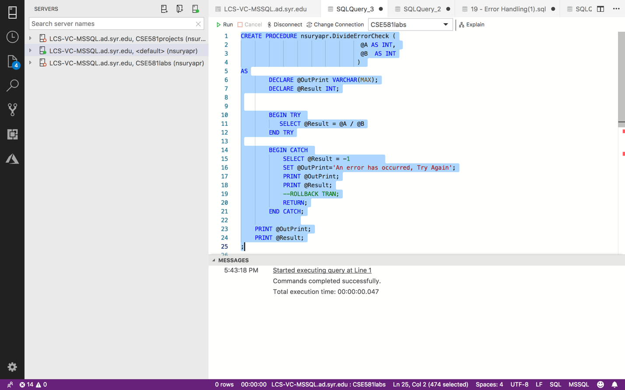

1. Execute the SP with input A = 10, B = 2. Provide a **screenshot** of execution, showing the result as well as error message, if any.

Script:

EXEC nsuryapr.DivideErrorCheck 10,2

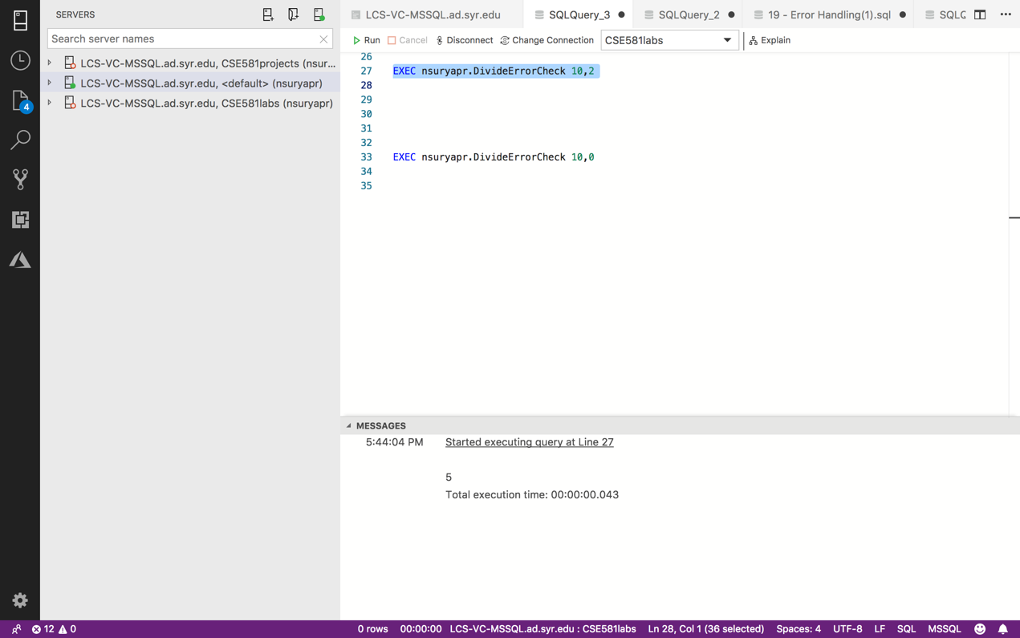

1. Execute the SP with input A = 10, B = 0. Provide a **screenshot** of execution, showing the result as well as error message, if any.

Script:

EXEC nsuryapr.DivideErrorCheck 10,0

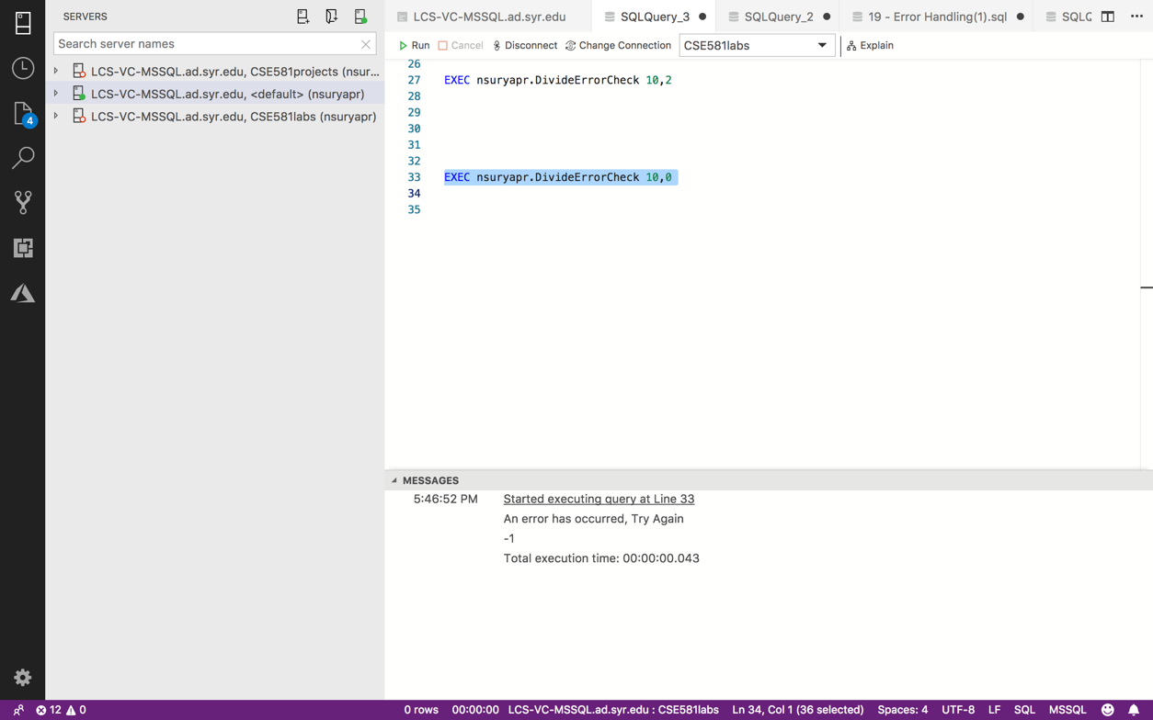

1. I would recommend using the TRY/CATCH block